ASSIGNMENTS ON DIGITAL MARKETING

NAME : SUGUMARAN A
DEPARTMENT : B.E.BIOMEDICAL ENGINEERING
COLLEGE: 8151 DHANALAKSHMI SRINIVASAN INSTITUTE OF
TECHNOLOGY
NAANMUDHALVAN COURSE : DIGITAL MARKETING
NM TEAM ID : NM2023TMID02352
NM ID : 81B2F1019BBFE8EA90443DBB2718D81F

ASSIGNMENT 1:
Create a blog or website using Blogspot and WordPress. Customize
The theme design and post new article with 500 words.
Website: https://wordpress.com/post/goldencra.wordpress.com/10

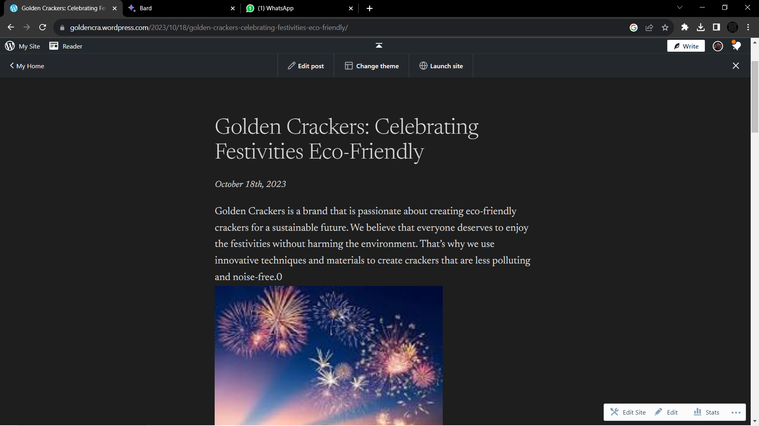

ASSIGNMENT 2:
Create a new Facebook business Page and Post one social media poster for your brand.
Website: https://www.facebook.com/profile.php?id=61550825429412

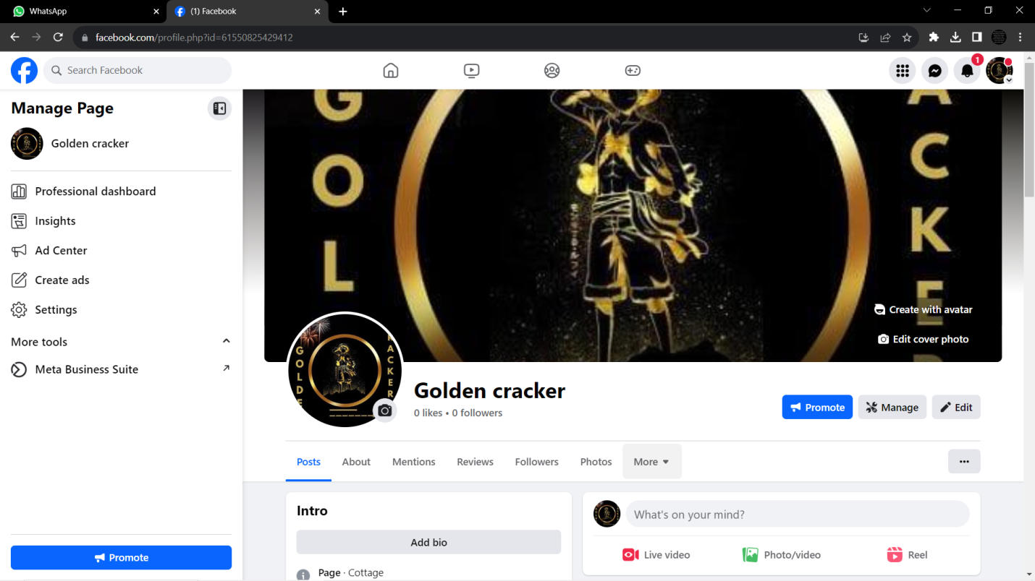

ASSIGNMENT 3:
Create and design a social media advertisement poster using Canva



.

ASSIGNMENT 4:
4.Create email newsletter design using MailChimp or Canva tool.

